1st [Prototype Usability Test](https://touro.instructure.com/courses/92143/assignments/734864/submissions/82529):

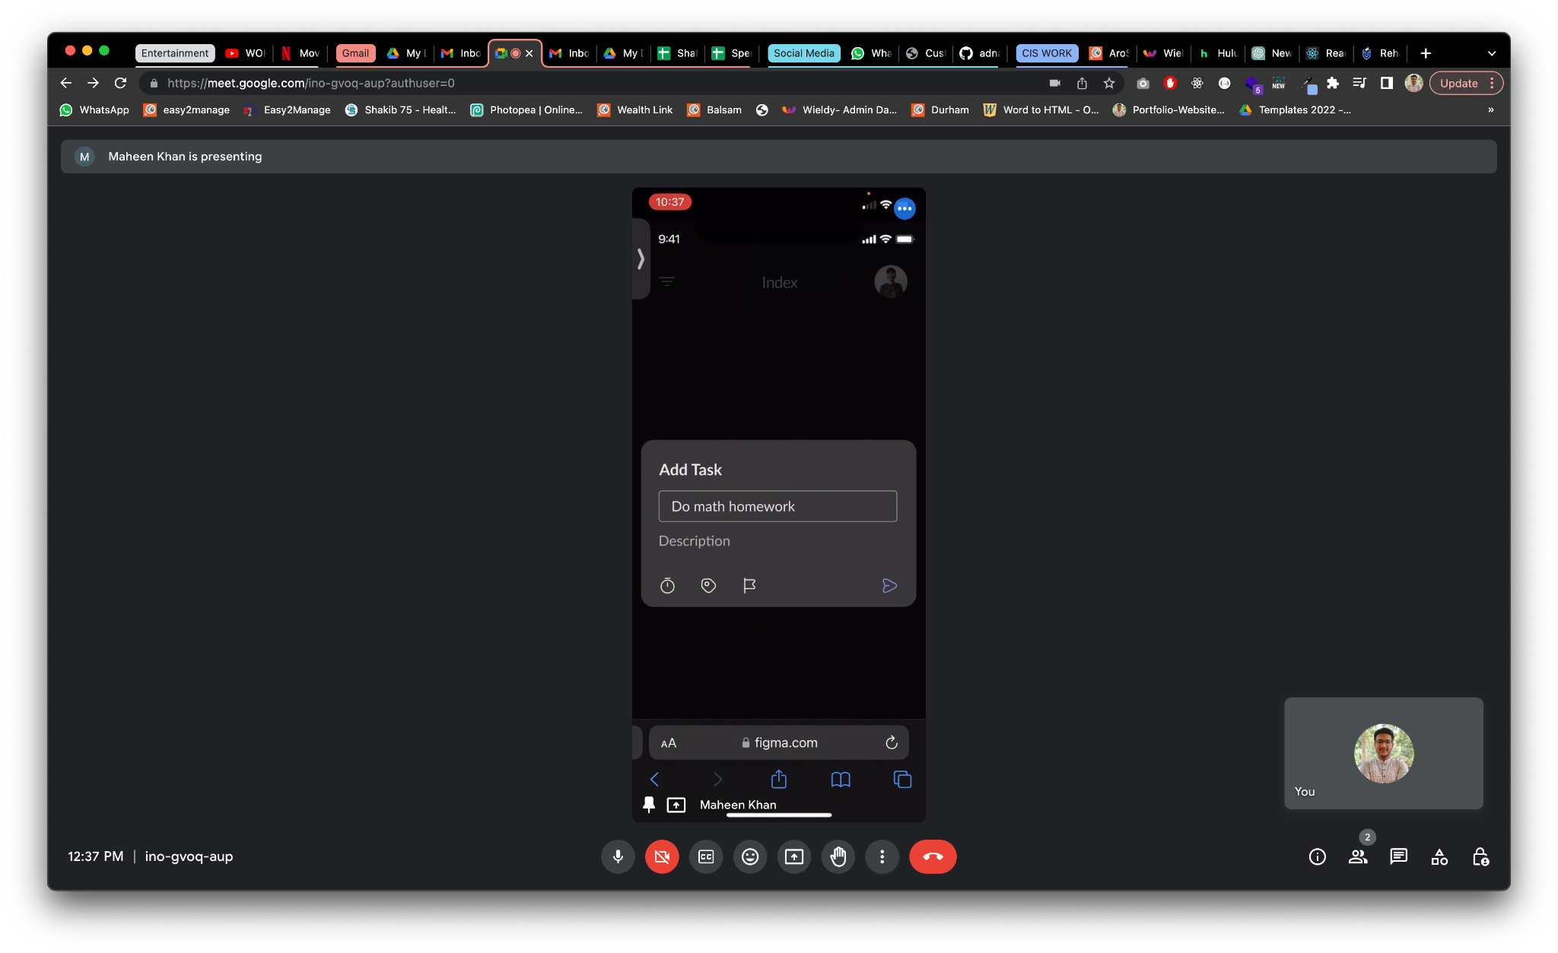

The first user was able to log in successfully and effortlessly add tasks and categories. However, during the process of adding a task, they noticed the absence of a cancel button on the screen. Consequently, they suggested that I incorporate a cancel button to allow for an easy return. Subsequently, I have implemented this feature after conducting the necessary testing.

2nd [Prototype Usability Test](https://touro.instructure.com/courses/92143/assignments/734864/submissions/82529):

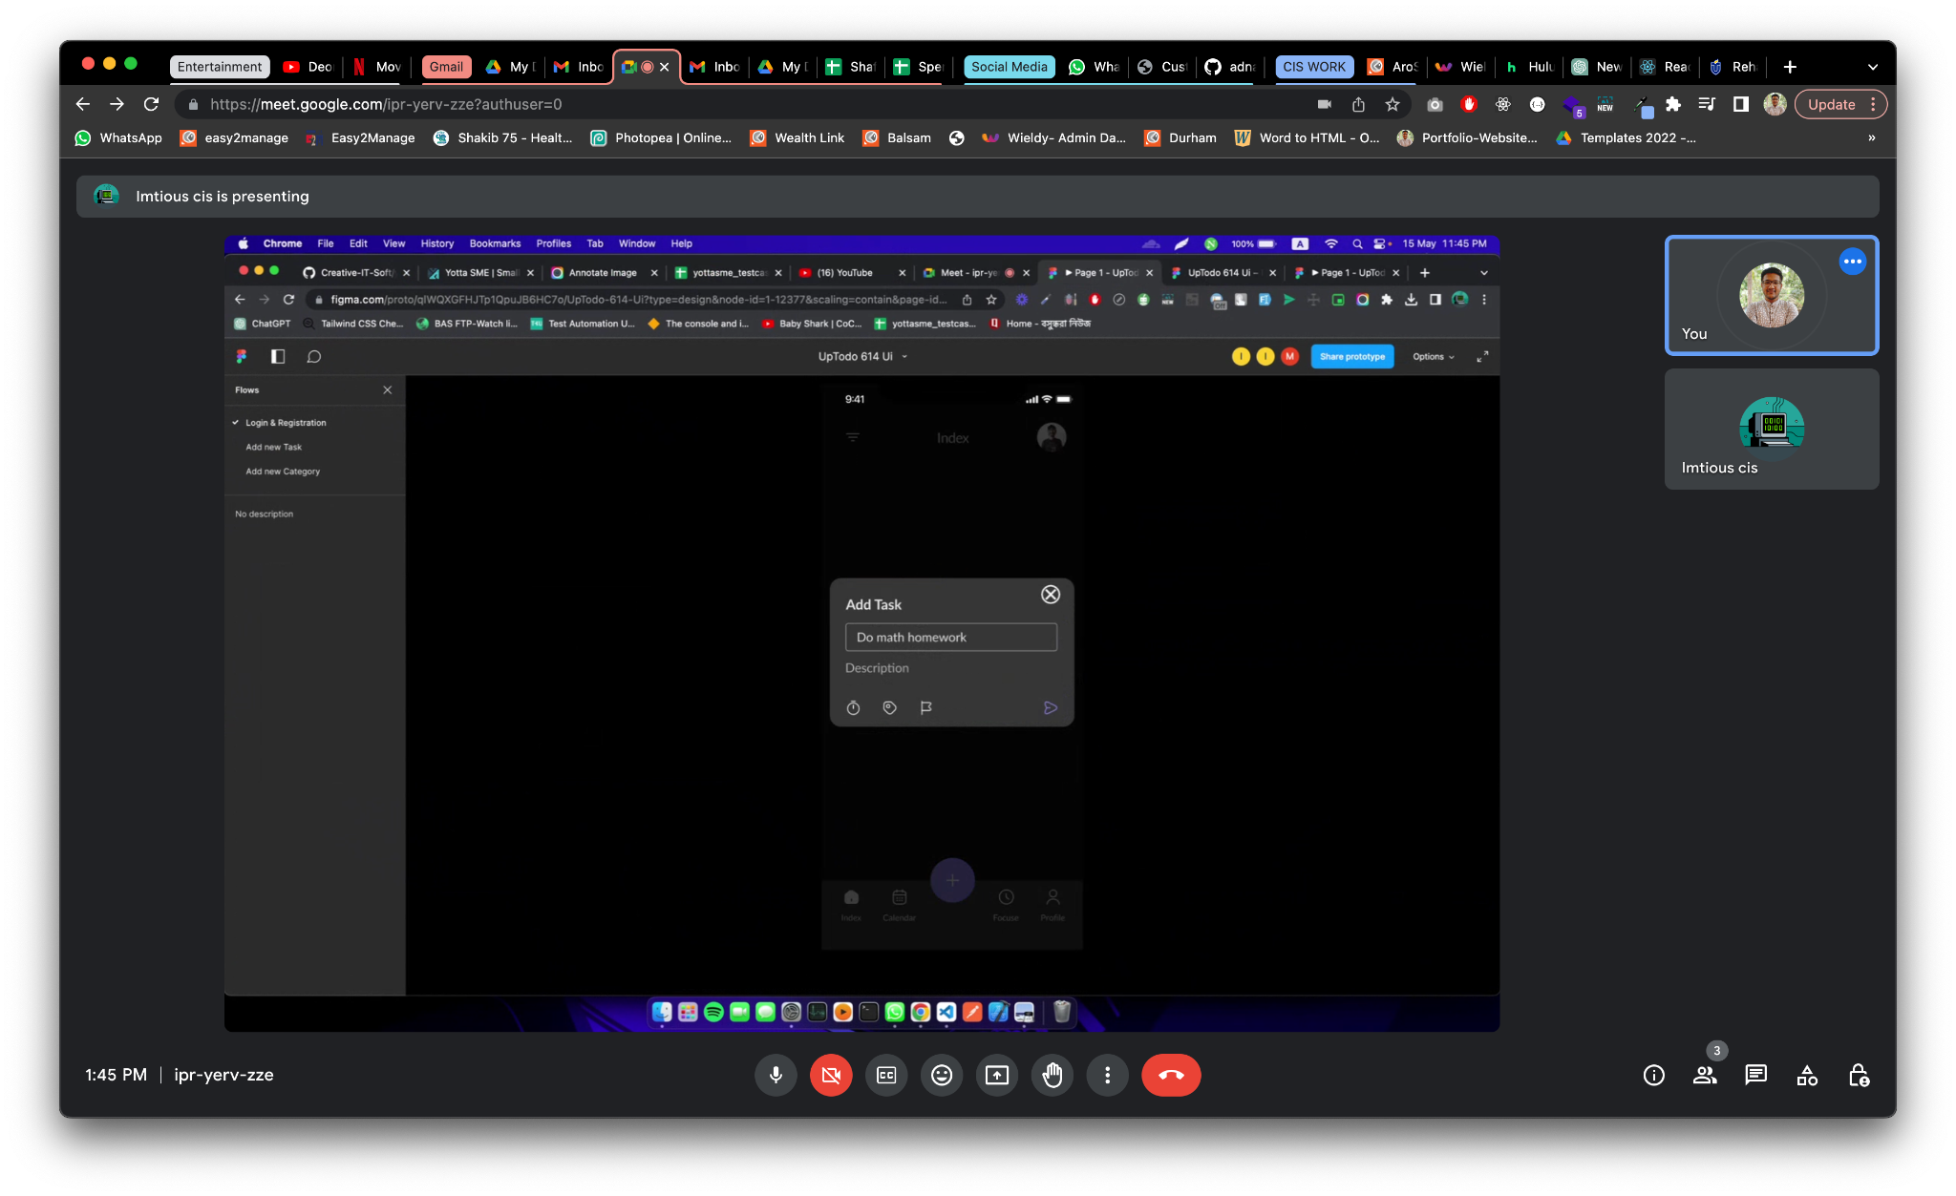

During the second usability test, the overall process proceeded without any issues. However, the participant experienced confusion when attempting to add a new task due to the absence of clear labels for the icons. Consequently, it is necessary for me to implement the addition of descriptive labels beneath the icons to enhance clarity and user understanding.

3rd [Prototype Usability Test](https://touro.instructure.com/courses/92143/assignments/734864/submissions/82529):

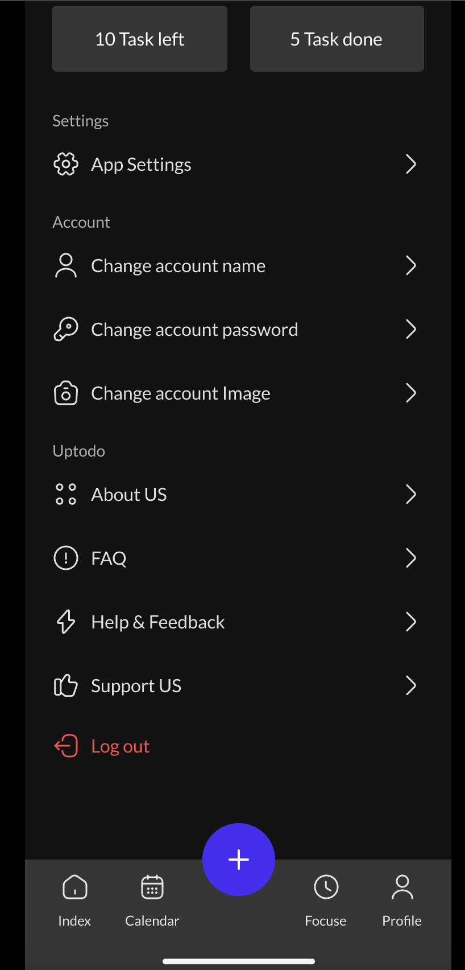

During the third usability test, the participant did not grant permission to capture a full screenshot; however, I managed to capture a screenshot of the phone screen. Despite this setback, the participant was able to successfully complete the assigned tasks. However, when attempting to log out, they encountered an issue due to my oversight in connecting the corresponding button. With the exception of this minor setback, the overall test proceeded smoothly.